**Staffordshire University**

**Faculty of Computing, Engineering and Technology**

**Computer Systems Security**

**Encryption Techniques and Implementation**

**By**

**Harry Clewlow (C012952A)**

**Contents**

1. Introduction Page 3
2. Critical Review of Techniques Page 3-7
3. Selection and Justification of Techniques Used Page 7-8
4. Evidence of Success Page 8-9
5. Appendix A
   1. User Guide Page10-15
6. Appendix B
   1. Class Diagram Page 16
7. Appendix C
   1. Test Input and Output Files Page 17-23
8. Appendix D
   1. Commented Code Listing Page 24-32
9. Appendix E
   1. References Page 33

**Introduction**

The aim of this assignment was to first a develop an application in either Java, C or C# to encrypt and decrypt text read from a file and output to a separate file, the application must be able to run on a university computer and to secondly produce a report that critically evaluates various encryption and decryption techniques that convert plaintext into ciphertext and vice versa.

This report presents a critical review of encryption and decryption techniques by the analysis of their strengths and weakness and presents the implementation of such an application in Java and includes a justification of techniques used in the application, evidence of success, a user guide, code design elements, test input and output files and commented source code.

**Critical Review of Encryption and Decryption Techniques**

Encrypt is the process of encoding data usually messages or information so that other users cannot read or make sense of it, but authorized users can. There are several different encryption techniques that are used to create an encryption algorithm, the main techniques used are substitution and transposition which is also called permutation.

Substitution techniques aim to alter the statistical pattern of a symbols occurrence, this is to produce a combination of symbols that are no more likely than another combination of symbols in doing so tis maximises the entropy. The three types of substitution are monoalphabetic, polyalphabetic and polygraphic substitution. [2]

Monoalphabetic substitution is when the same substitution is used throughout the entire message, this is done by writing out the alphabet in some order to represent the substitution alphabet this may be by shifting or reserving. Some of ciphers which use this technique are the Caesar cipher, Atbash cipher and Keyword cipher. The Caesar cipher is a very simple encryption method that uses confusing to produce a result that looks like gibberish. This is accomplished by the Caesar cipher where it shifts letters in the plaintext three letters down in the alphabet because of this frequency analysis can be performed on the ciphertext it has become easy to decrypt the message. Figure 1 below shows a diagram of the caser cipher which shows the plaintext of the alphabet being shifted three places down the alphabet. [3]



Figure 1 Caesar Cipher Diagram [1]

The advantages of monoalphabetic ciphers such as the Caesar cipher is that they are easy to memorize and implement for the authorized parties to decrypt the ciphertext due to not having any cipher key or written instructions because of the fixed length shift of three. The major weakness of these cipher is that a secure encryption shouldn’t allow third parties to use pieces of the ciphertext to predict the pattern used for encryption. [1]

Polyalphabetic substitution is when the substitution varies throughout the entire message, this type of substitution uses multiple substitution alphabets and are usually written into one table that is 26x26 so that it can produce 26 full ciphertext alphabets. Some of the encryption methods which use this substitution are the Beaufort cipher, Autokey cipher and the most popular the Vigenère Cipher. [3]

The Vigenère Cipher uses several Caesar ciphers in sequence with different shifts as shown below in Figure 2. At different stages of the encryption process the cipher alphabet used depends on the repeating cipher key.

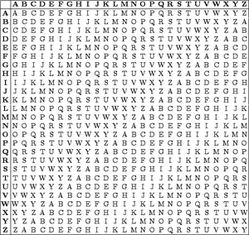

Figure 2 Vigenère Cipher Table [1]

For example, we will encrypt “ATTACKATDAWN”, whoever is sending the message will choose a cipher key which will be repeated until it matches the length of the plaintext, for this example the cipher key will be “LEMON” and once repeated the cipher key will be “LEMONLEMONLE”, each letter in the cipher key corresponds to the row on the Vigenère cipher table.

In this example the first letter of the plaintext is paired with the first letter of the cipher key so A is paired with L, the place where row L and column A intersects is the new letter for the ciphertext. This is repeated for every letter in the plaintext until the entire message is encrypted using the cipher key, the reserve is done when the user wishes to decrypt messages that have been encrypted using a Vigenère cipher, an example encryption is shown below. [4]

Plaintext: ATTACKATDAWN

Cipher key: LEMONLEMONLE

Ciphertext: LXFOPVEFRNHR

The Advantage of using polyalphabetic substitution is that it harder to break than a monoalphabetic and is also less vulnerable to frequency analysis due to it not having a one to one correspondence. One of the flaws with cipher that use polyalphabetic substitution is that the key has to be as long as the plaintext, which will double the amount of data used to encrypt or decrypt. Also he key must be known by the sender and receiver, this cause problems if either forgets the key which would result in the message being unreadable if the wrong key is used.

Polygraphic substitution is when the substitution is performed with two or more groups of letters or symbols. Some encryption method with uses this substitution are the Playfair cipher, Bifid cipher, Trifid cipher and the Four-square cipher.

The advantage of polygraphic substitution is that the frequency distribution is much flatter than other techniques that only substitute individual letters, this helps by making frequency analysis more difficult. Although polygraphic substitutions are more secure than monoalphabetic substitution it can still be cracked by hand.

Transposition techniques aim to alter the order of the plaintext according to a specific algorithm, this is to produce the ciphertext that has the same letters or symbols in as the plaintext but the order in which they occur has changed so that the ciphertext becomes a permutation of the plaintext. There are several different type of transposition some of which are Rail Fence, Route cipher and columnar transposition. [2]

In Rail Fence transposition the plaintext is written downwards on successive “rails” of an imaginary fence hence the name, a new column is started once you have reached the bottom of the previous one, for this kind of transposition the number of “rails” is used as the cipher key. [3]

For example, we will encrypt “THISISASECRETMESSAGE”, whoever is sending the message will choose the number of rails for which the plaintext will be written on, for this example the cipher key will be 3 so we will have three rails or rows when encryption the plaintext.

Rail Fence: T S A C T S G

H I S R M S E

I S E E E A J

Ciphertext: TSACTSGHISRMSEISEEEAJGURL

The above shows the plaintext after it have been put on to rails where J has been used as placeholder so that the ciphertext is condensed and regrouped. To complete the Rail Fence transposition we need to put the ciphertext above onto one line, for this will take each row and add it to the end of the previous one so that third parties are not aware of it being encrypted using Rail Fence transposition. To decrypt the message you must know the number of “rails” used you can then break the ciphertext into equal group of letters for each “rail” and then stack them on top of each of them so you can read the message off vertically. [3]

An advantage to using transposition techniques is that it will move the order a plaintext and will disguise it from any third parties trying to read the plaintext. Although transposition techniques can be broken by statistical methods because pairs of successive characters will have a typical likelihood, also if the message is short then some letters will not appear which makes it possible to determine what words do not exist in the plaintext. A major disadvantage of transposition is that is has a high demand for memory to encrypt or decrypt the ciphertext which has had transposition done to it.

A block cipher works by encrypting groups of letters from the plaintext into ciphertext. An example diagram below shows how block ciphers work.

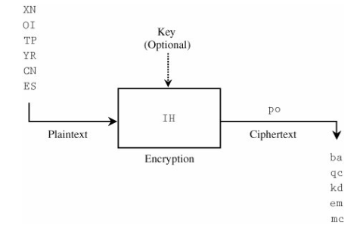

Figure 3 Block Cipher Diagram

Advantages of block encryption is that it has a high diffusion rate so that information about a plaintext symbol is connected to several different ciphertext symbols. The disadvantages of using block encryption is that the encryption process is very slow because it must wait for the entire block of plaintext to be received before starting the encryption also the if an error occurs it will change all the characters in the block not just the one when using stream ciphers. [1]

A stream cipher converts each symbol or letter of plaintext straight into ciphertext, the encryption depends only on the symbol and then key used to encrypt the plaintext. An example diagram below shows how stream ciphers work

.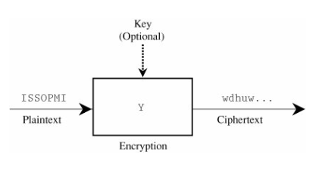

Figure 4 Stream Cipher Diagram

Advantage of stream encryption is that the speed of transformation is fast in comparison to block encryption because it doesn’t rely on symbols or letters from the plaintext so it can be encrypted as its being read. Also stream ciphers have a very low error rate because each symbol or letter is encrypted separately so if an error occurs it will only effect that one specific character. The disadvantage of stream ciphers is that it has a low diffusion rate so that information about a plaintext symbol is connected directly to the ciphertext symbol. [1]

All the encryption and decryption techniques above will a ciphertext that has either of the following characteristics. Confusion is where the statistical properties in the ciphertext is not related to the statistical properties of the original plaintext and can be achieved by complex substitution. Diffusion is where each symbol in the ciphertext is dependent upon many of the symbols in the plaintext and elements of the key used to encrypt and can be achieved by permutation and multiple rounds. [1]

Although both substitution and transposition are have been used to encrypt and decrypt messages separately modern day algorithms use them both in different orders and repeat them several times which are called rounds. In my algorithm I will be choosing several of the techniques details above and combining them.

**Selection and Justification of Techniques Used**

My encryption algorithm I will use both substitution and transposition techniques to encrypt plaintext into ciphertext, I will also generate a key from the users password to use which this algorithm. Below I have explained and given examples of the algorithm I will implement.

The password will be put into uppercase and then all non-alphabetic characters will be removed, then depending on the length of the password and the ASCII value of each character addition or subtraction to the ACSII value will be done as shown in the example below.

User Password: HARRY = 72 65 82 82 89

Cipher Key: RKHHORKHHO = 82 75 72 72 79 82 75 72 72 79

Once the key has been generate I will be passing the plaintext through a Vigenère cipher using the generated key after I will perform several substitutions, permutations and transpositions or my own devising as shown below to scramble the message.

The following steps are performed on the original text:

1. Vigenère cipher preformed using generated key (substitution)
2. Every three characters will have fourteen added to their ASCII value if in range (substitution)
3. Every nine characters will have three subtracted from their ASCII value if in range (substitution)
4. The first character will be swapped with the ninth (permutation)
5. The whole string will be reversed (permutation)

Original Text: this is a text

Cipher Text: KRLAYJWhPWV

The decryption method is the step that make up the encryption method but reversed to unscramble the message.

The following steps are performed on the cipher text:

1. The whole string will be reversed (permutation)
2. The ninth character will be swapped with the first (permutation)
3. Every nine characters will have three added to their ASCII value if in range substitution)
4. Every three characters will have fourteen subtracted from their ASCII value if in range substitution)
5. Vigenère cipher preformed using generated key substitution)

Cipher Text: KRLAYJWhPWV

Original Text: THISISATEXT

I have decided to generate the key by removing all non-alphabetic characters and then shifting each character in the password by its length so that it will produce a cipher key that can be used in a Vigenère cipher but will also mask the cipher key from the password so if someone discovers the password used to encrypt the software they will not because to decrypt the message without knowing the key generation method. See Appendix D for source code.

The reason that I have decided to put the plaintext through a Vigenère cipher is so that the plaintext encrypted to use as a base for the other operation I will perform also this will reduce the effectives of a frequency analysis if I had only done the other operations. I have choosing to use several substitution during the encryption process so that I can remove the chances of frequency analysis because the process changes every 3 and every 9 characters each will be different to the previous. I have also swapped the first character with the ninth so that the message is even more scrambled, and finally I have decided to reverse the ciphertext so that any attempt at decryption with the wrong key will result in gibberish.

**Evidence of Success**

I will be analysis the success of my encryption algorithm by using Claude Shannon’s five characteristics that identify a good cipher, I will also be comparing the resulting ciphertext that is produced from several different sample plaintexts, the effect of using different keys on the same sample plaintext and the effect that different size plaintext have on the time it takes to encrypt.

Shannon’s first characteristic which states “The amount of secrecy needed should determine the amount of labour appropriate for the encryption and decryption”. My algorithm complies with this characteristic due to masking the plaintext in such a way so it produces a complex ciphertext that will deter or hold off casual interceptors as shown in the simple test files in Appendix C. [1]

Shannon’s second characteristic which states “The set of keys and the enciphering algorithm should be from complexity” The keys that are generated with my algorithm compile with this characteristic because of simply being the product of adding the length of the password to the ASCII values of the password, this simple method can be remembered easily by the user if they were to perform the algorithm by hand as shown in the test shown in Append C where the key has been specified. [1]

Shannon’s third characteristic which states “The implementation of the process should be as simple as possible”. My algorithm is simple enough to encrypt and decrypt plaintext by hand with a tolerable implementation time, this is because the idea behind the encryption is a simple Vigenère cipher with extra operations which form my date of birth March 14th 1993. [1]

Shannon’s fourth characteristic which states “”Errors in ciphering should not propagate and cause corruption of further information in the message”. The algorithm that I have implemented uses a polyalphabetic cipher so an error can occur then reading the row or column of the Vigenère cipher, also when preforming the shifts afterwards because the encryption and decryption is handled by a computer these errors are unlikely. [1]

Shannon’s fifth characteristic which states “The size of the enciphered text should be no longer than the text of the original message”. The ciphertext that is produced by my algorithm is either smaller or the same size of the plaintext depending on any special characters or numbers in the plaintext, the algorithm also removes all the spaces so that lengths of any words in the ciphertext is distorted as shown in Appendix C. [1]

The ciphertext that are produced by the algorithm contain a mixture of upper and lower case letter and a wide range of special characters that are supported by ASCII, which hide the original message and the method used to encrypt the message making this a success encryption method because third parties cannot easily see the algorism pattern see Appendix C for example ciphertext. Also because the algorithm preforms several techniques depending on the length of the length of the user password and the length of the plaintext a variety of different results can be produced for plaintexts that differ in size or use different keys.

When testing the effect the size of the plaintext has on the time it takes to encrypt, I found that when testing 10,000 character long plaintext it was encrypted almost instantly but as I increased the length of the plaintext by 500% so the plaintext is 50,000 characters long it was encrypted in 2 seconds, I then increase the length of plaintext again to 100,000 characters and it was executed in 5 seconds, I finally increased the length of the plaintext to 150,000 and it took 16 seconds to execute, the tests can be found in Appendix C. the time texts stated above show that the algorithm is efficient and can handle large files.

Overall the algorithm that I have devised is successful because it takes in plaintext and outputs a message that is completely different from the original, where letters have become number and special characters and would take someone a long time to uncover the algorithm.

**Appendix A**

**User Guide**

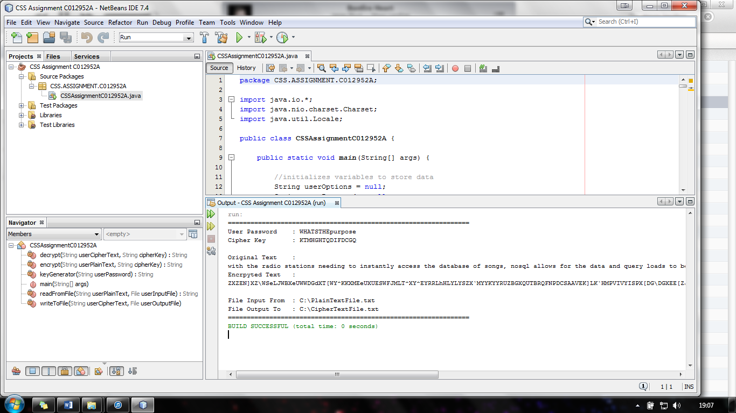

**Encryption & Decryption Software Implemented using Java**

**User Guide**

**By Harry Clewlow**

**Contents**

1. Overview Page 1
2. Using the Application
   1. Setting up the files Page 1
   2. Preparing to Run the Application Page 2
   3. Encryption using Application Page 3
   4. Decryption using Application Page 3-4
   5. Closing the Application Page 4
   6. Viewing Resulting Encryption or Decryption Files Page 4

**Overview**

The encryption & decryption software implemented using java application guide will explain and demonstrate how to use the applications features such as encryption and decryption, troubleshooting any problems that might occur, some frequently asked question and a glossary of any technical terms used.

**Using the Application**

**Setting up the files for with plaintext and cipher text**

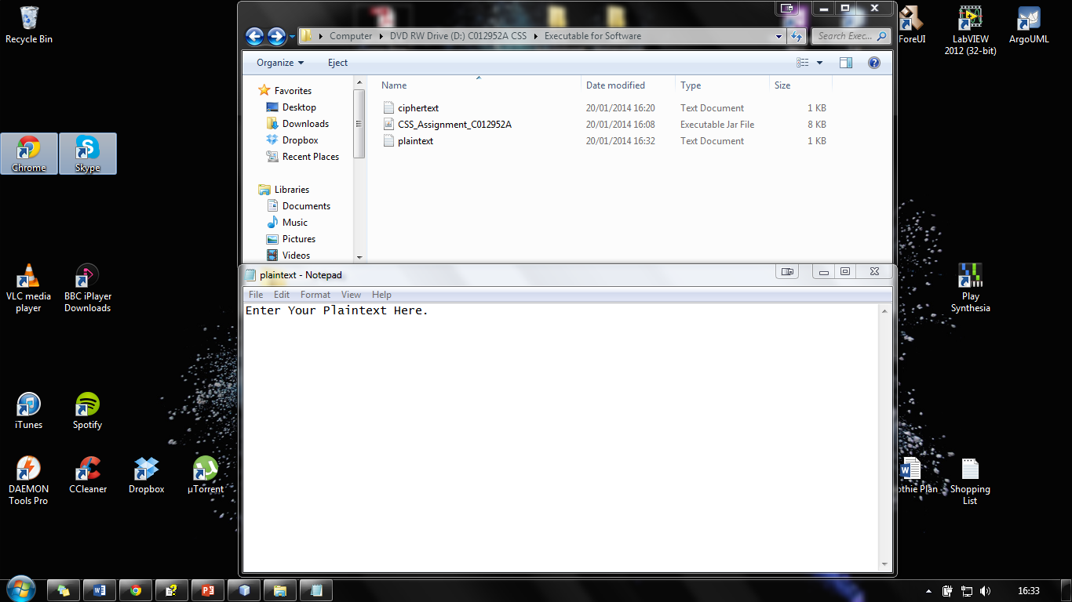

Figure 5 Setting up Plaintext and Ciphertext Files

Before you start the application make sure that you have entered the text that you wish to encrypt into the correct file. Navigate to the following directory **“D:\Executable for Software”** and open the file **“plaintext”**. Enter the text you wish to encrypt and make sure you save the file by selecting **“File->Save”** then close the file by selecting **“File->Exit”** or using the cross in the top right corner.

**Preparing to Run the Application**

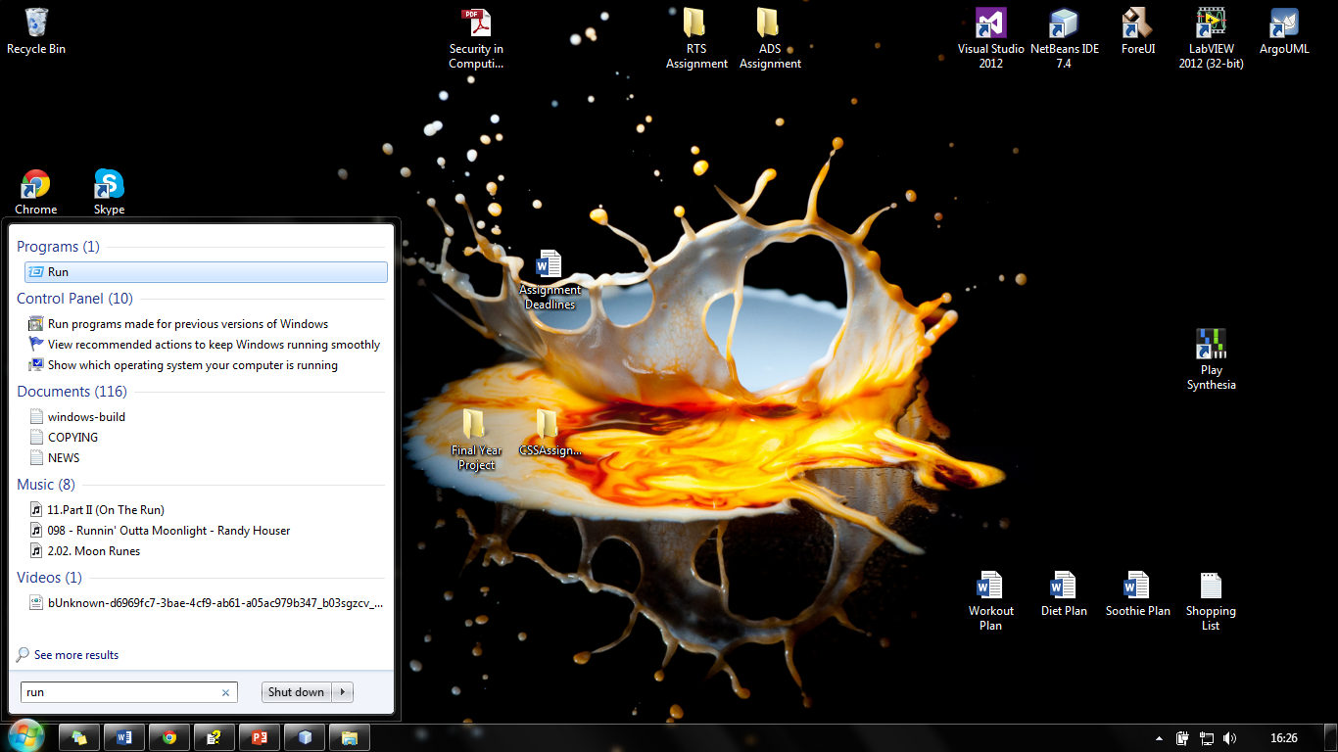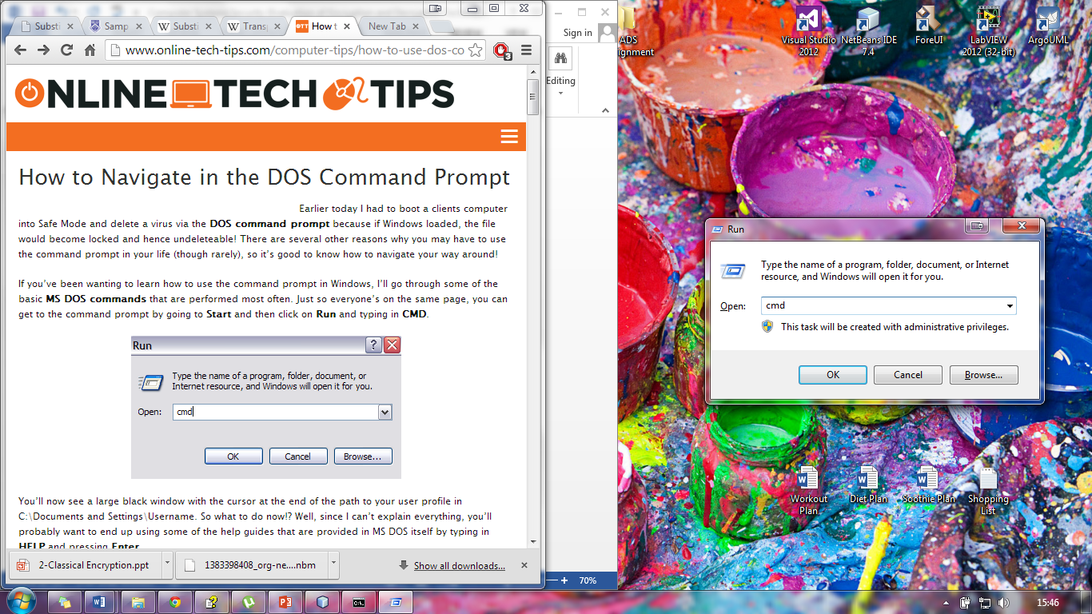

Figure 6 Start Menu and Run Window

In order to run the application you will be to open Windows Command Processor to do this will be to click the **“Start”** button located at the bottom left of the screen and type **“Run”** click the result at the show at top as shown by the image on the left above, a window like the image on the right will appear type **“cmd”** and press **“OK”**.

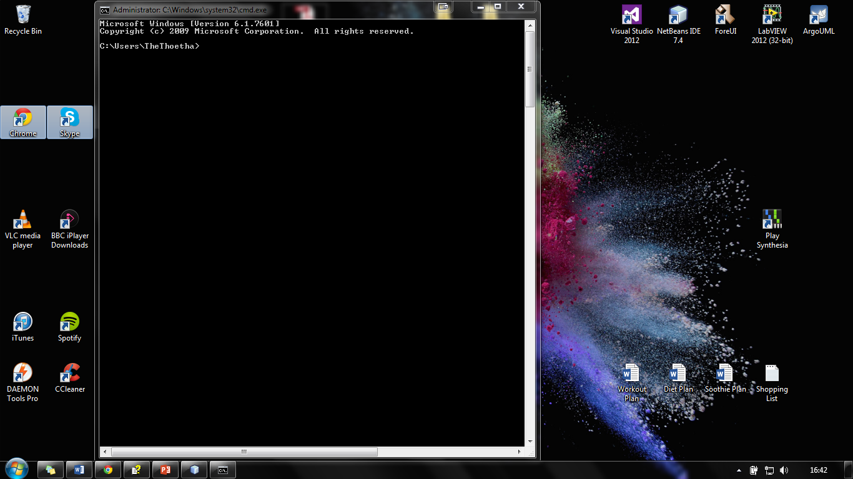

Figure 7 Example CMD Window

A window like the one above should appear, you will be to navigate to the correct directory to access the information on the disk that has been provided with this report. To do this type “D:” and press enter this will take you to the drive where the disk is located, next type “CD Executable for Software” and press enter as shown below.

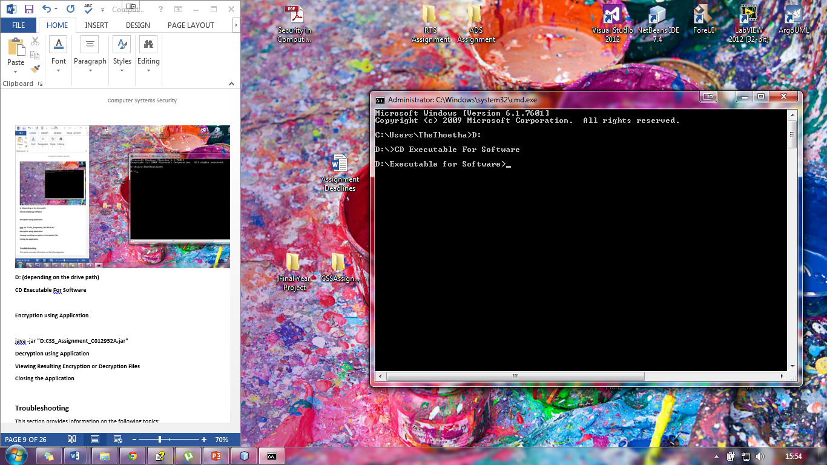

Figure 8 Example CMD after Navigation

Now you are ready to start the application to encrypt and decrypt any message that you have put into the files previously.

**Encryption using Application**

When you are ready to encrypt some text you will need to use the following format to use the application.

**Java -jar "D:CSS_Assignment_C012952A.jar" [-e] Thisisthepassword D:plaintext.txt D:ciphertext.txt**

Which means:

**[-e]** - is the option to encrypt a file this can be change later for decryption.

**Thisisthepassword -** is a password from which program generates a key to use for encryption, you can enter any password you want as long as it is greater than 10 characters and less than 40.

**D:plaintext.txt -** is the plaintext file for encryption you can change the path is you wish but D:plaintext.txt is the default.

**D:ciphertext.txt** - is the ciphertext file produced by encryption you can change the path is you wish but D:ciphertext.txt is the default.

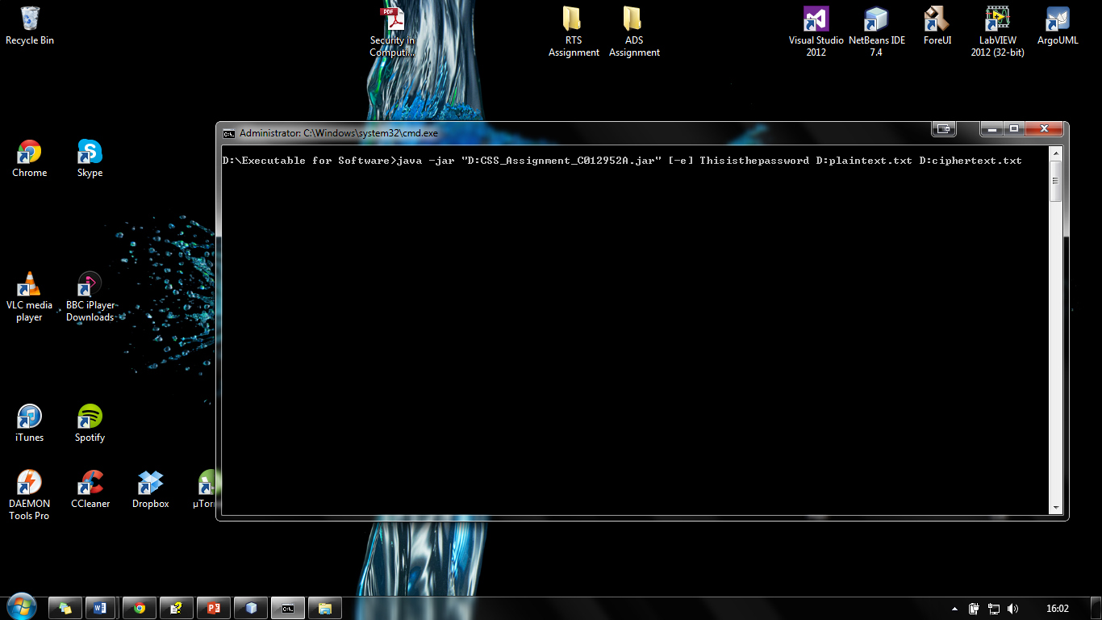

Figure 9 Example Encryption Line

The image shows an example of execute line in the command line window. Below shows the result when you press enter, it shows the user the password used to create the cipher key, the cipher key used for encryption, the original text, the encrypted, the file it has been input from and the file it is going to be output to.

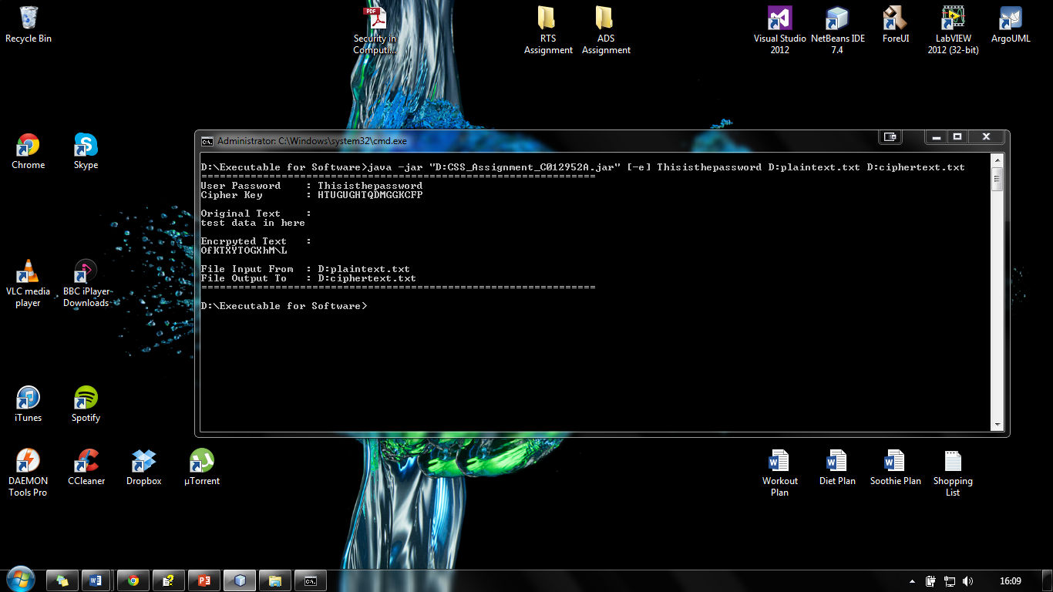

Figure 10 Example Result from Encryption Line

**Decryption using Application**

When you are ready to decrypt some text you will need to use the following format to use the application.

**java -jar "D:CSS_Assignment_C012952A.jar" [-d] Thisisthepassword D:ciphertext.txt D:plaintext.txt**

Which means:

**[-d]** – is the option to decrypt a file this can be change later for decryption.

**Thisisthepassword -** is a password from which program generates a key to use for decryption, you can enter any password you want as long as it is greater than 10 characters and less than 40.

**D:plaintext.txt -** is the plaintext file for decryption and will put the decrypted text into this file, you can change the path is you wish but D:plaintext.txt is the default.

**D:ciphertext.txt** - is the ciphertext file produced by encryption which is a file that you wish to be decrypted you can change the path is you wish but D:ciphertext.txt is the default.

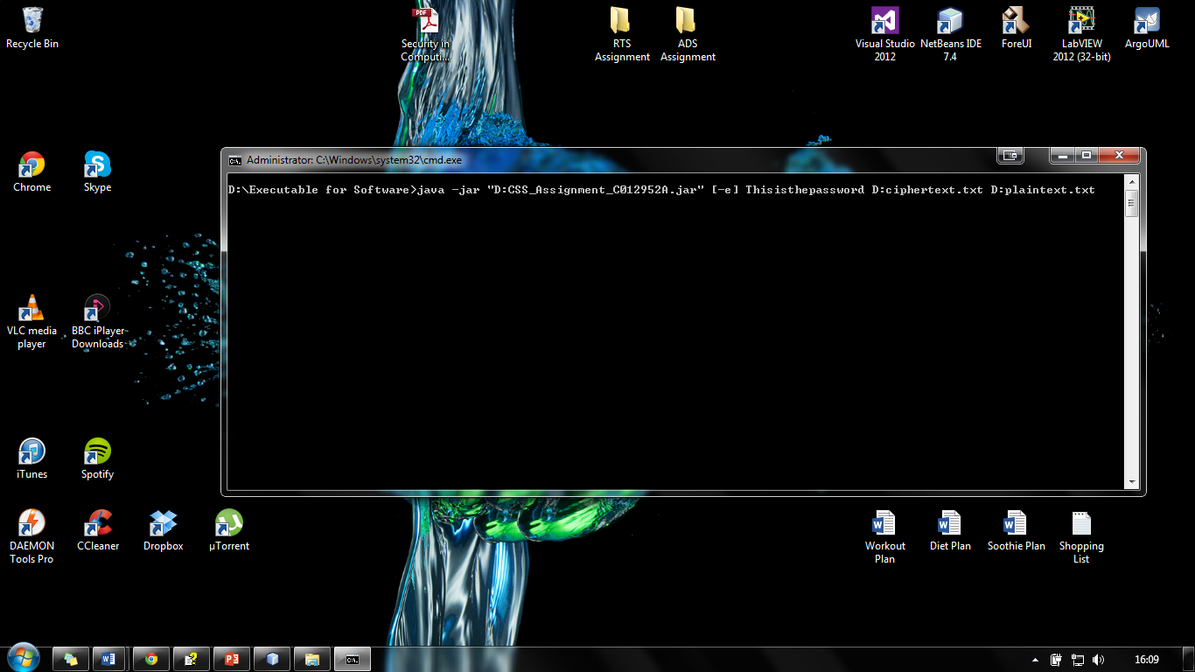

Figure 11 Example Decryption Line

The image shows an example of execute line in the command line window. Below shows the result when you press enter, it shows the user the password used to create the cipher key, the cipher key used for encryption, the original text, the encrypted text, the file it has been input from and the file it is going to be output to.

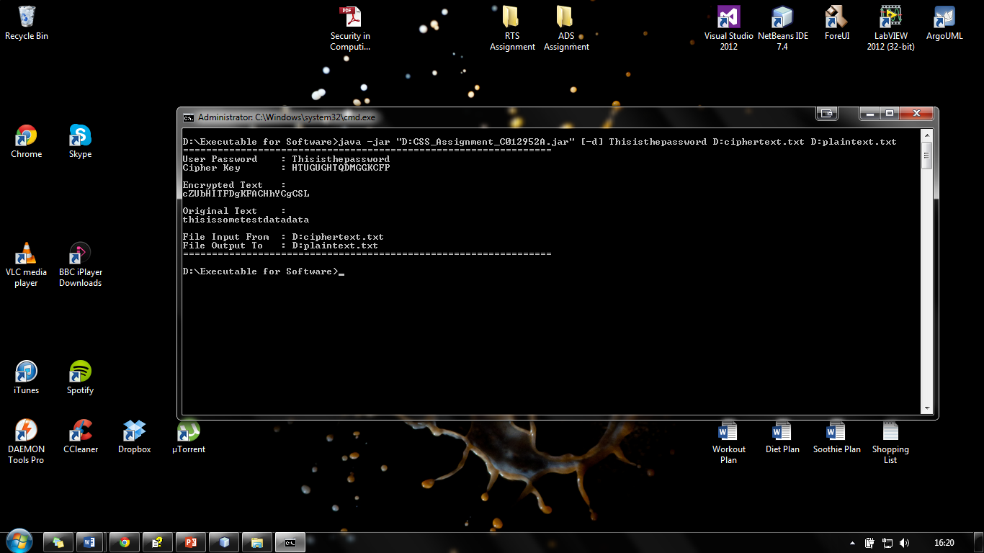

Figure 12 Example Result from Decryption Line

**Closing the Application**

When you have finished encrypting or decryption text from a variety of files you will need to close the command line window to do this press the cross in the top right corner of the windows as shown below.

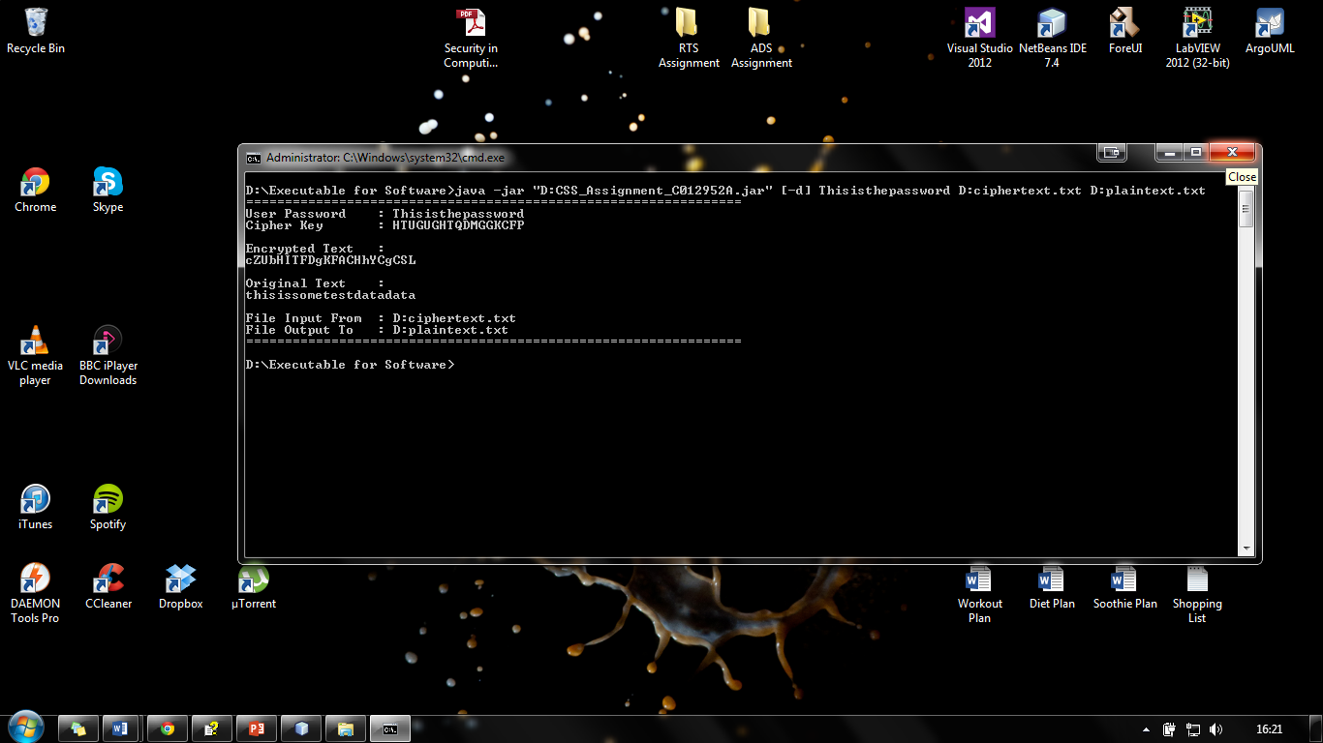

Figure 13 Closing the Application

**Viewing Resulting Encryption or Decryption Files**

If you wish to view either the ciphertext or the plaintext you can do so by navigating to the following directory **“D:\Executable for Software”** where both files are located.

**Appendix B**

**Class Diagram**

Below shows the class diagram of the application called EncryptionSoftwareAssignment.Java.

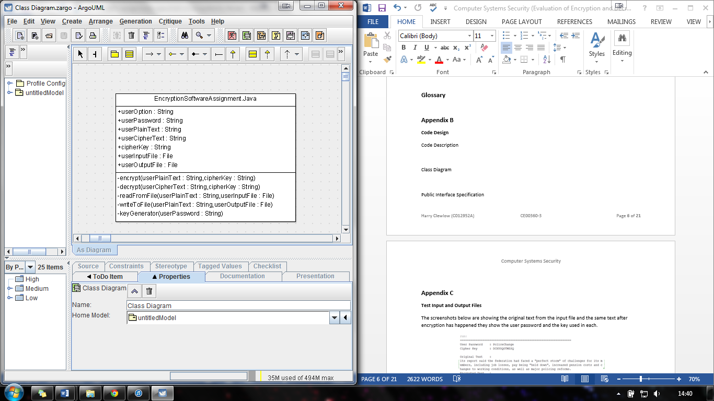

Figure 14 UML Class Diagram

**Appendix C**

**Test Input and Output Files**

The screenshots below are showing the original text from the input file and the same text after encryption has happened they show the user password and the key used in each.

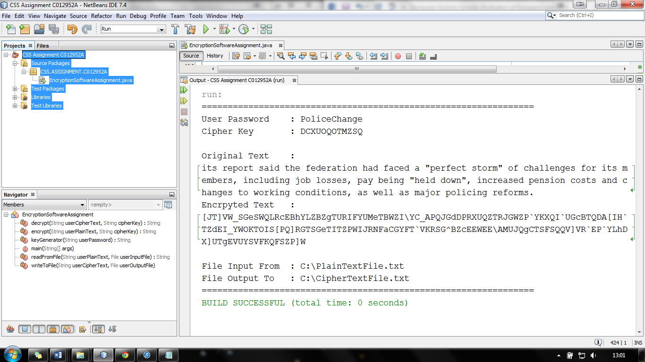

Figure 15 Text Before and After Encryption 1

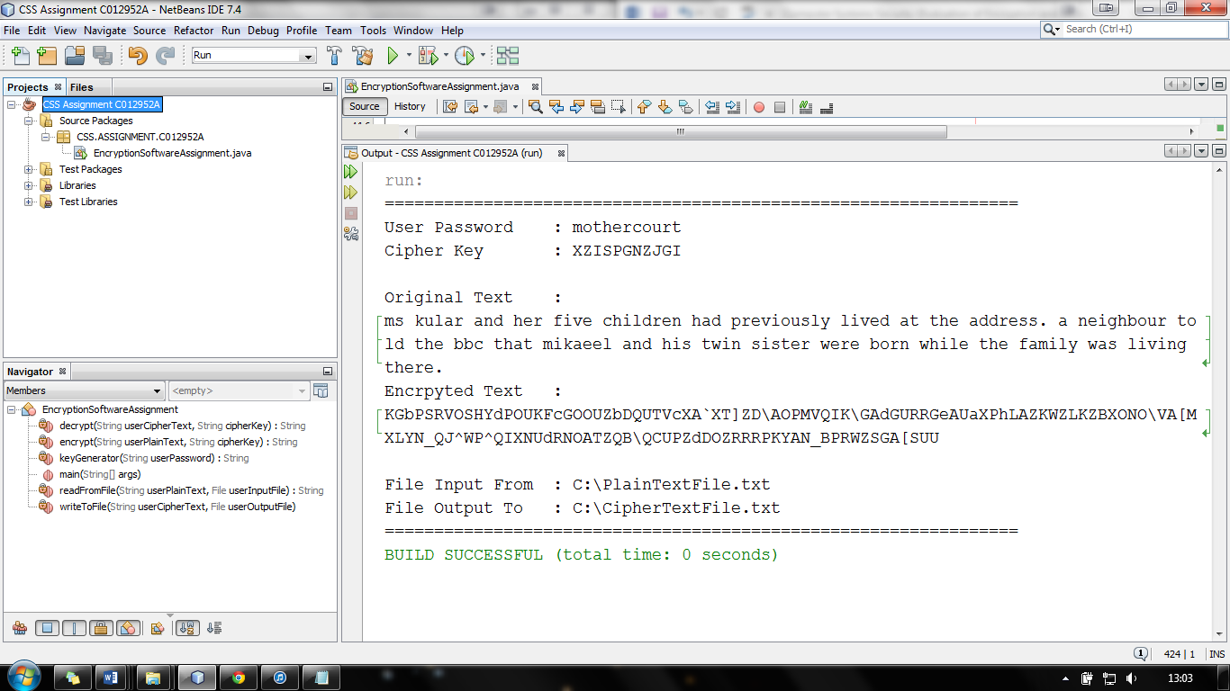

Figure 16 Text Before and After Encryption 2

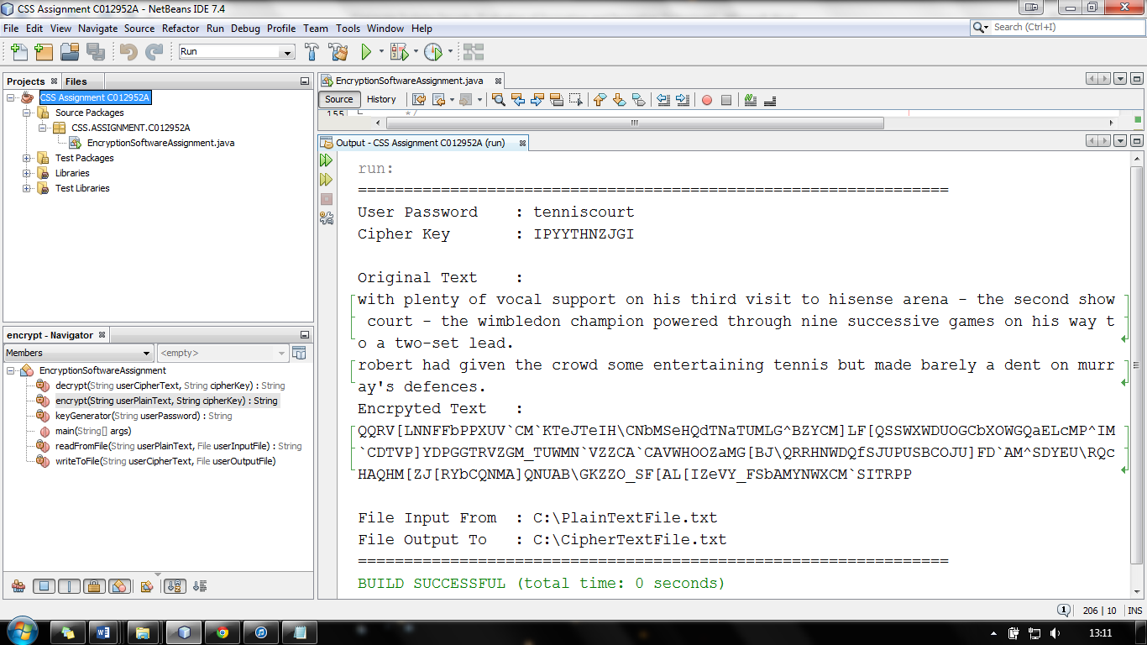

Figure 17Text Before and After Encryption 3

The screenshots below are showing what happens when the same text is encrypted using different key.

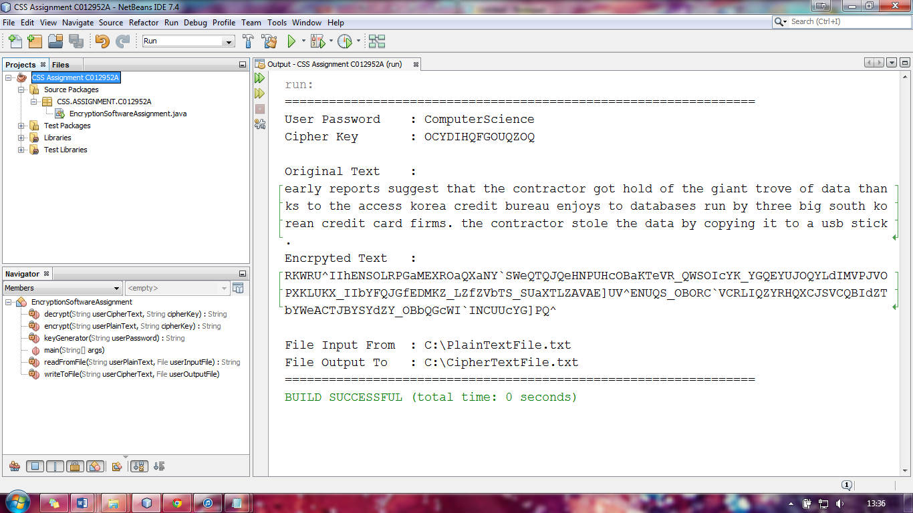

Figure 18 Same Text Encrypted With Different Keys 1

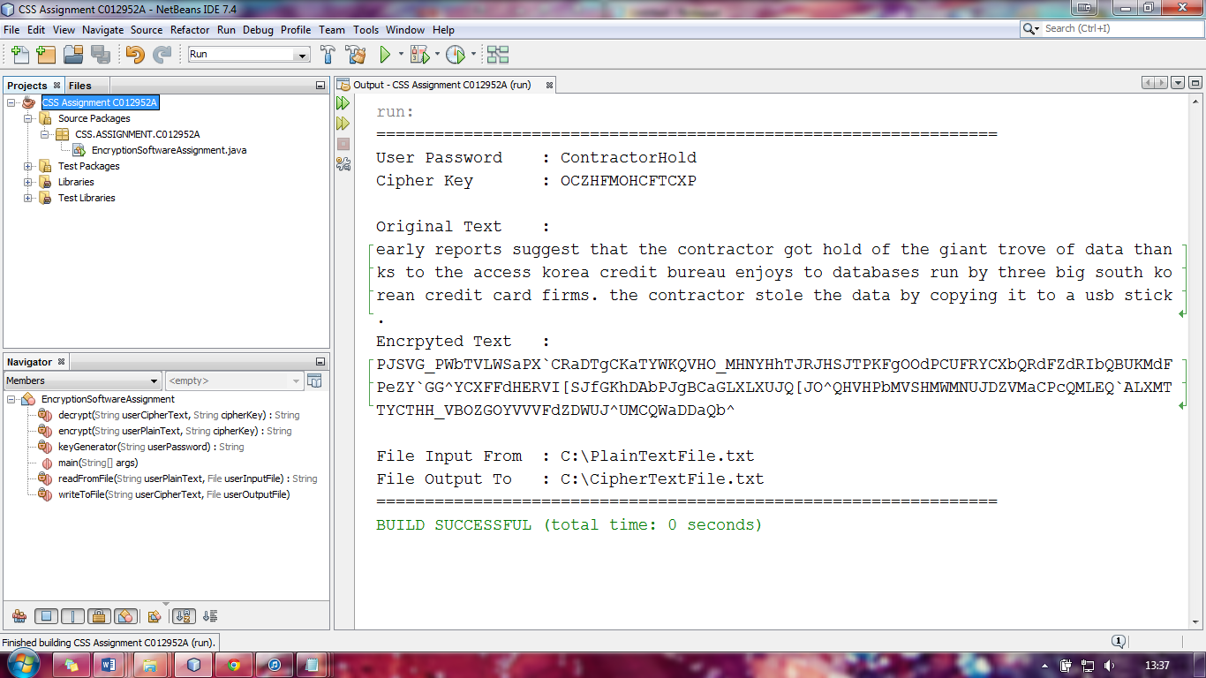

Figure 19 Same Text Encrypted With Different Keys 2

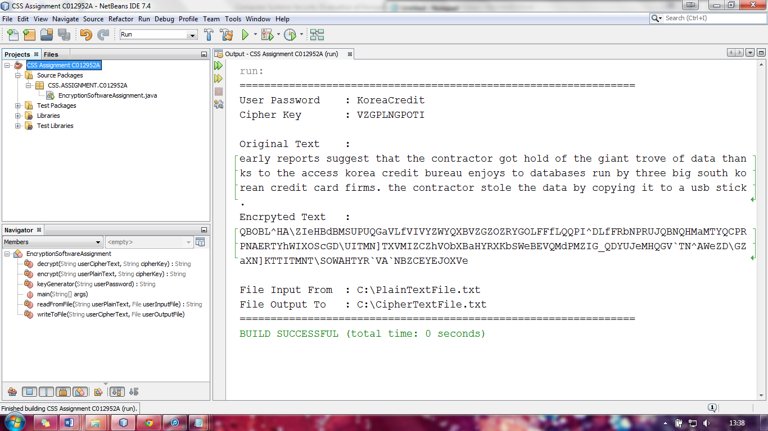

Figure 20 Same Text Encrypted With Different Keys 3

The screenshots below are showing another example what happens when the same text is encrypted using different key.

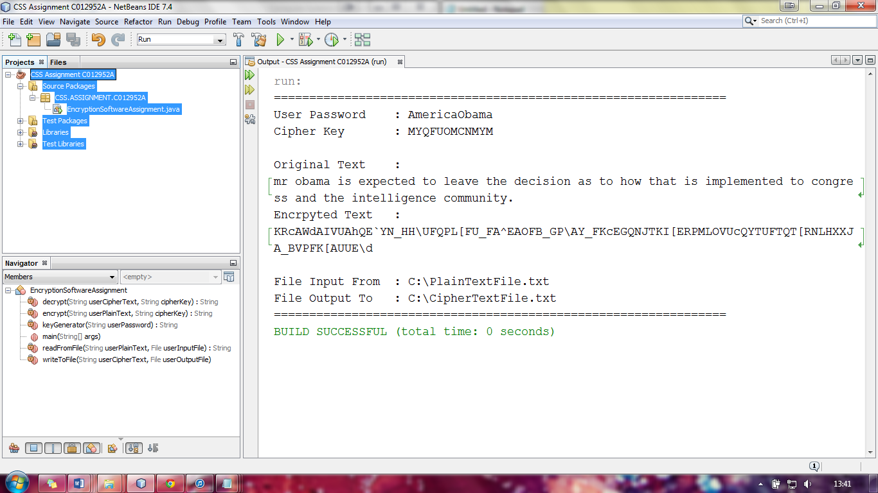

Figure 21 Same Text Encrypted With Different Keys 4

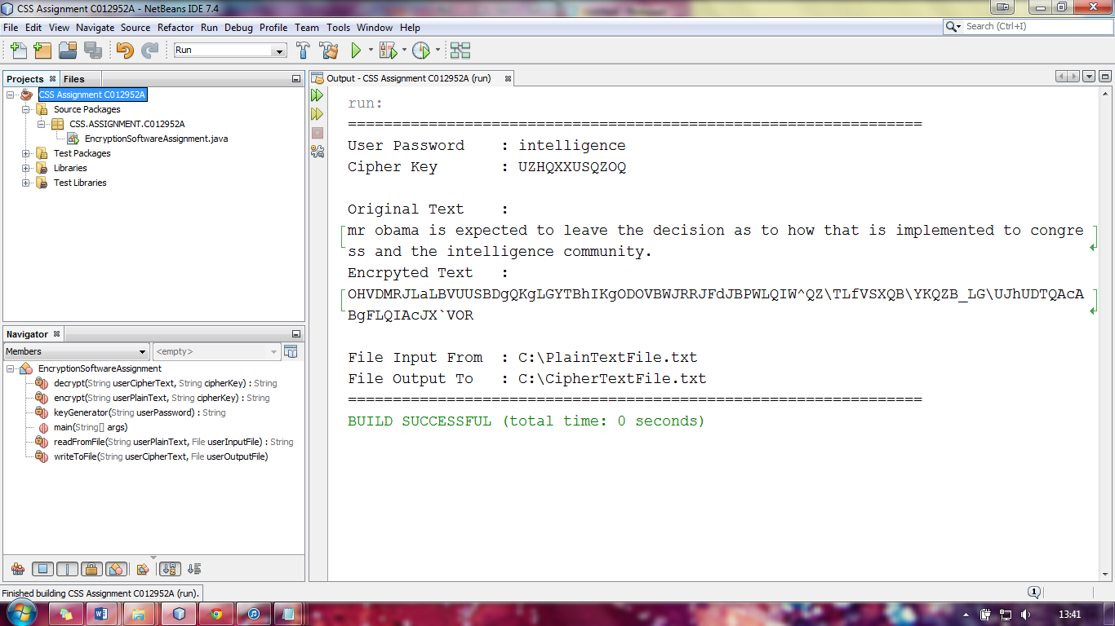

Figure 22 Same Text Encrypted With Different Keys 5

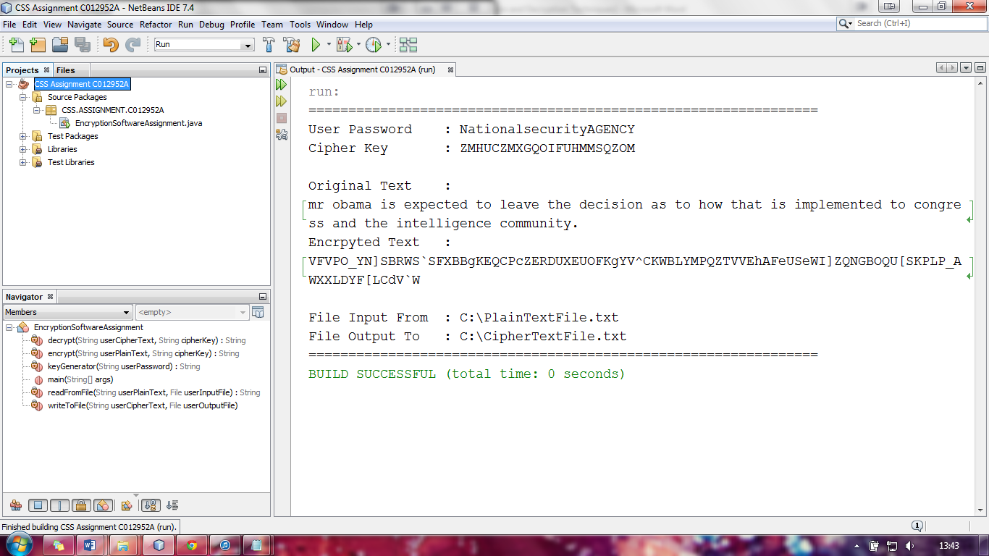

Figure 23 Same Text Encrypted With Different Keys 6

The screenshots below are showing what happens when different text is encrypted using same key.

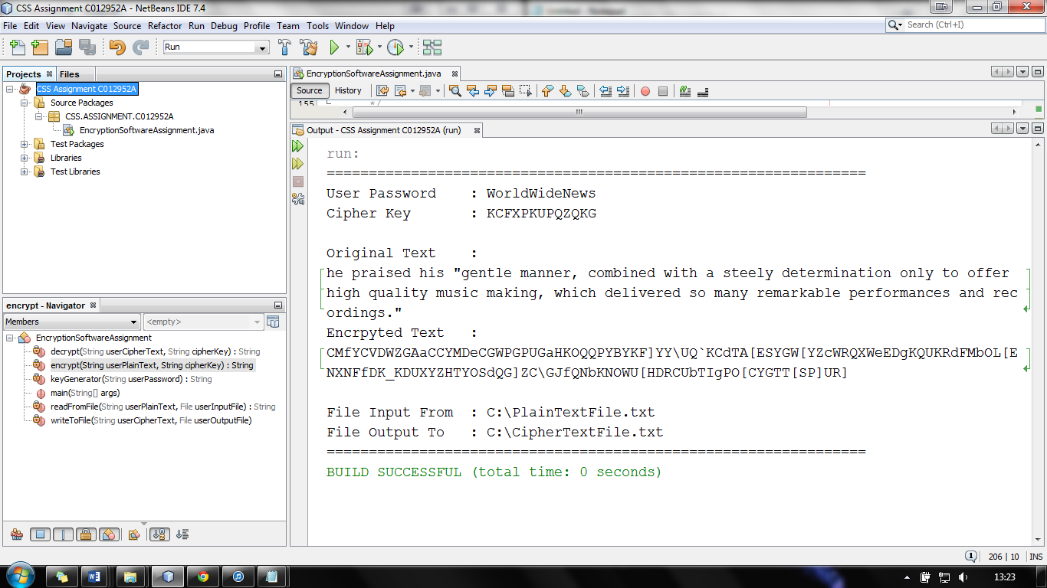

Figure 24 Different Text Same Key 1

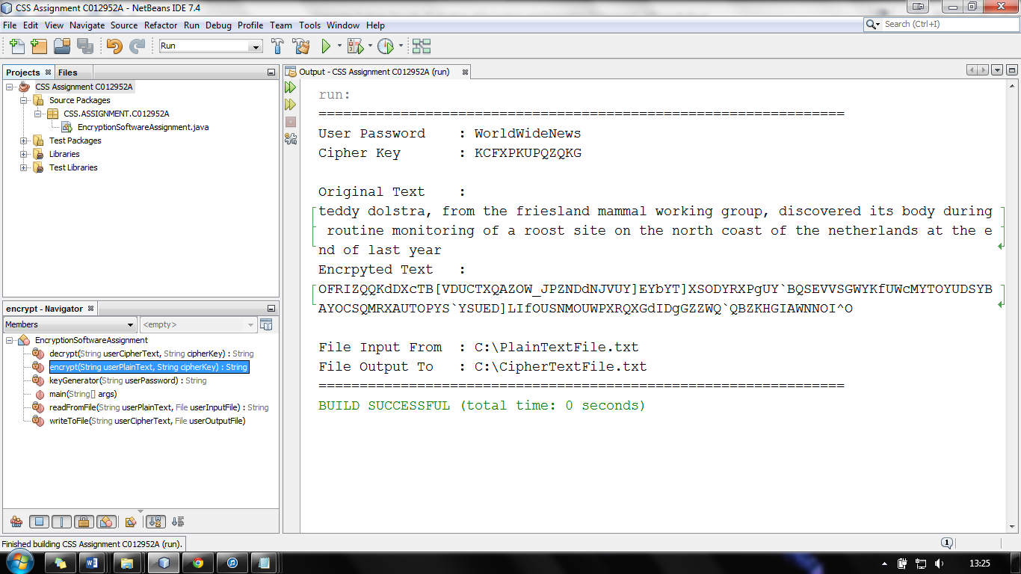

Figure 25 Different Text Same Key 2

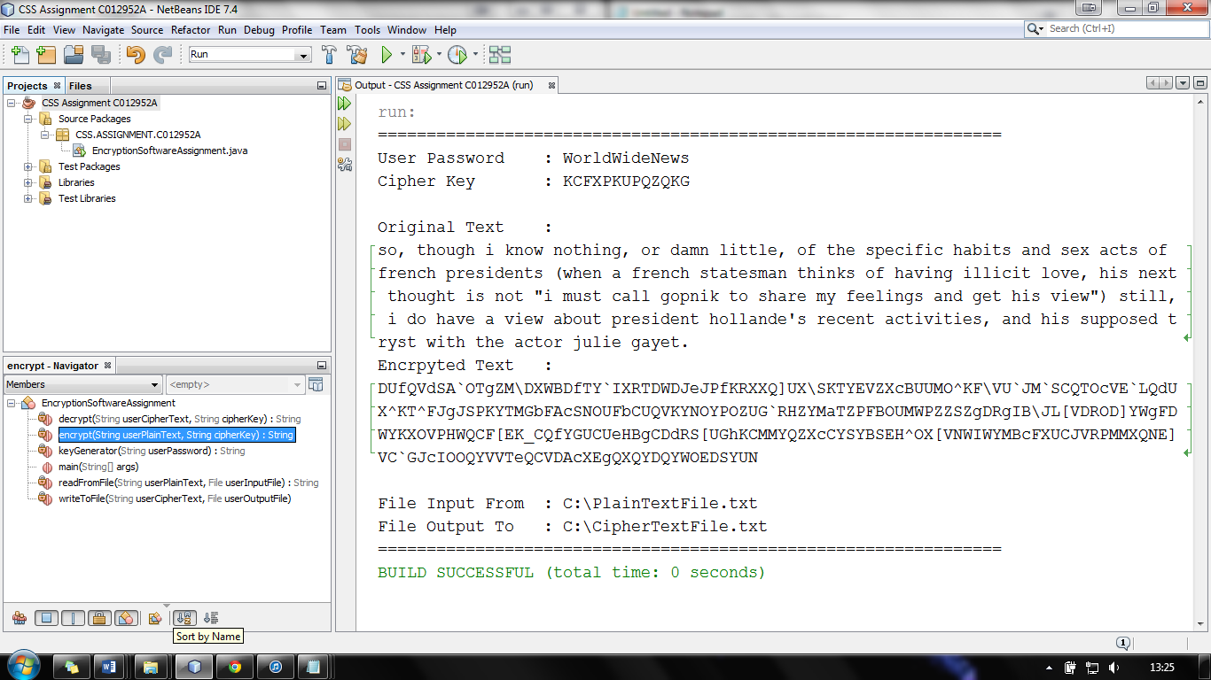

Figure 26 Different Text Same Key 3

The screenshots below are showing another example what happens when different text is encrypted using the same key.

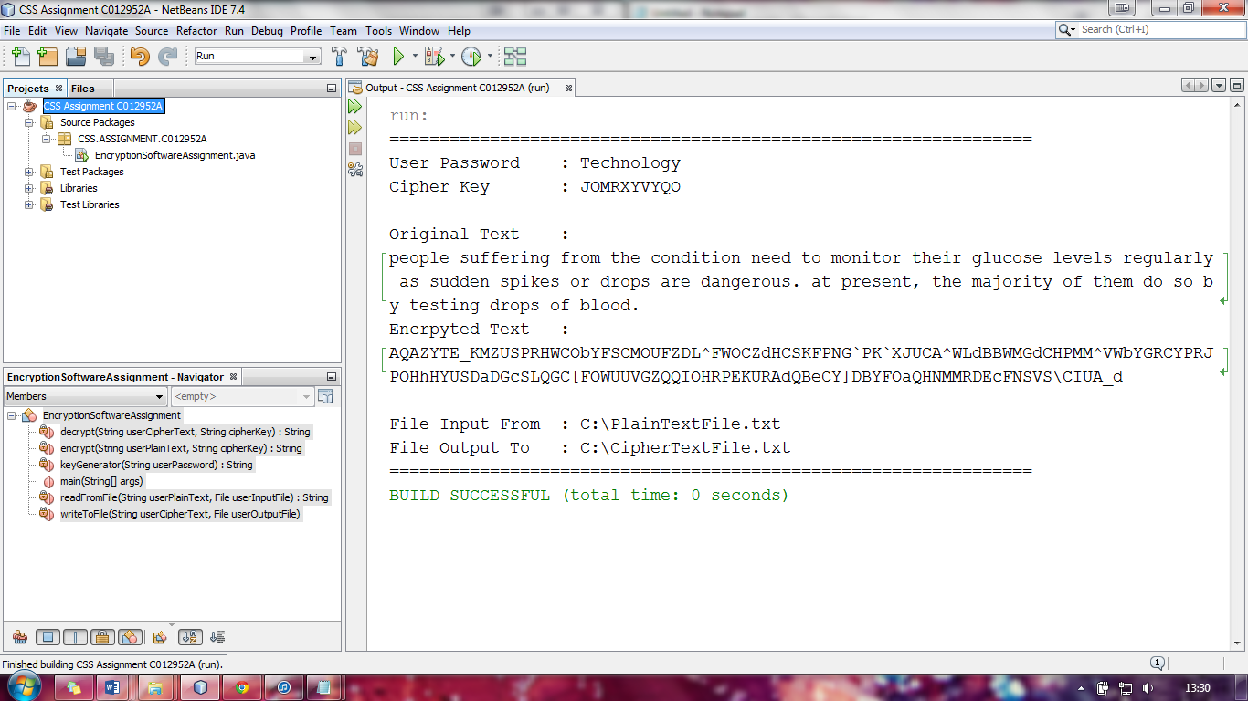

Figure 27 Different Text Same Key 4

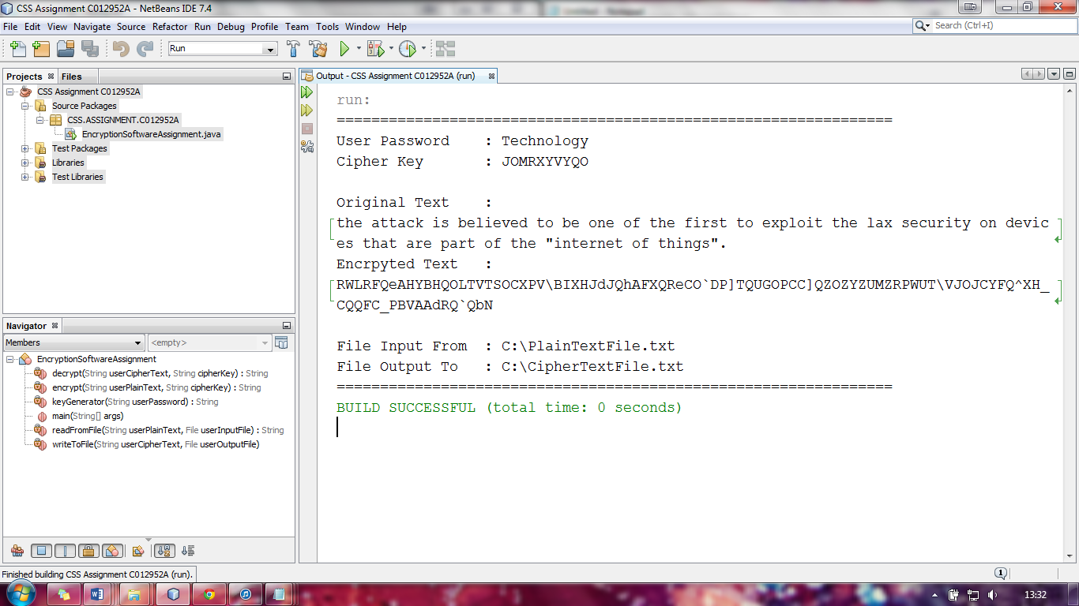

Figure 28 Different Text Same Key 5

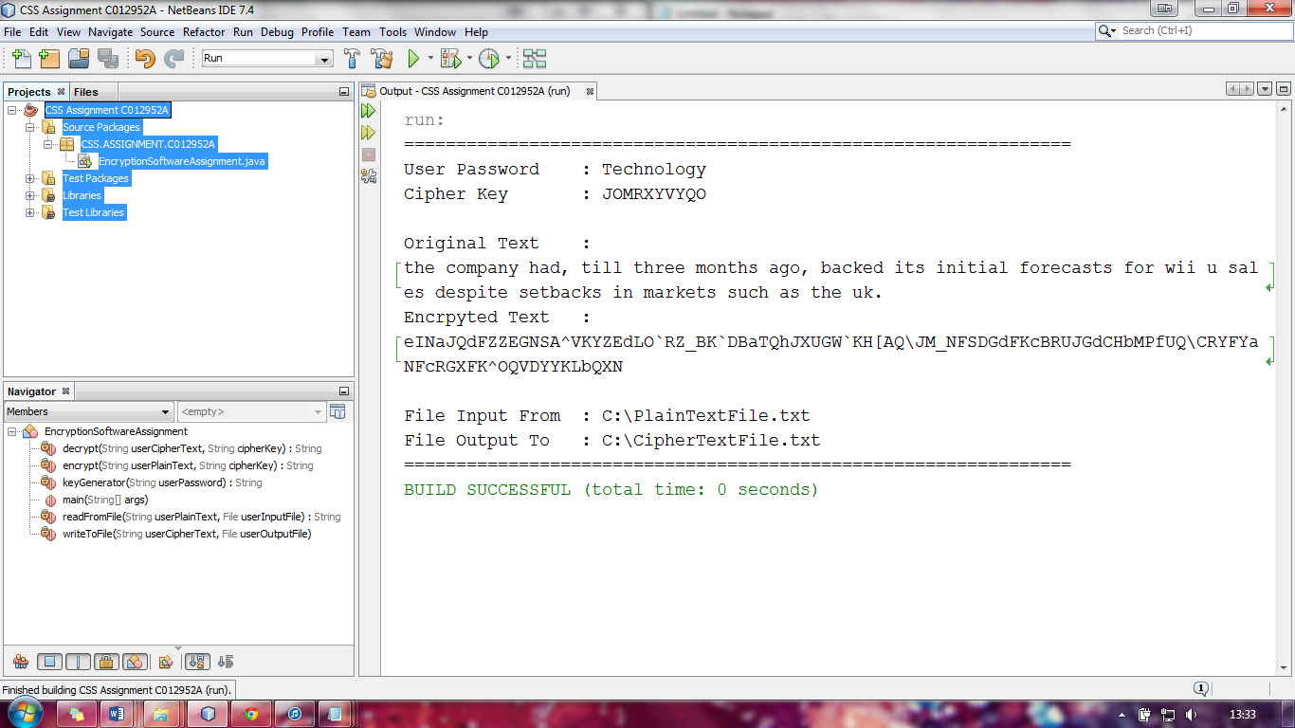

Figure 29 Different Text Same Key 6

**Testing the Time it takes to Encryption and Decryption Different Sizes of Files**

The following tests can be found on the CD provided with this assignment in the following directory D:\C012952A CSS\Example Tests\Timing Tests when testing the time it takes to encrypt and decrypt a file I used several different sized files ranging from files that had 10,000 characters in them up to files which had 150,000 characters in. The results are show below

Encrypting 10,000 characters

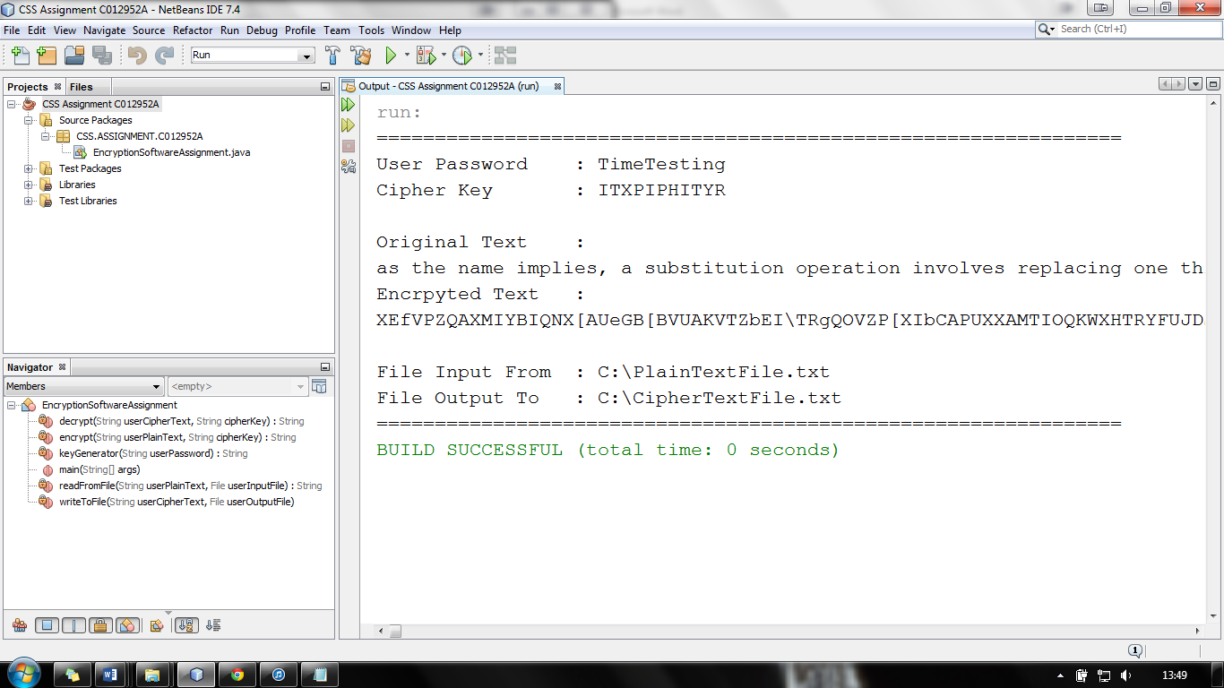

Figure 30 Encryption Time Test 1

Encrypting 50,000 characters

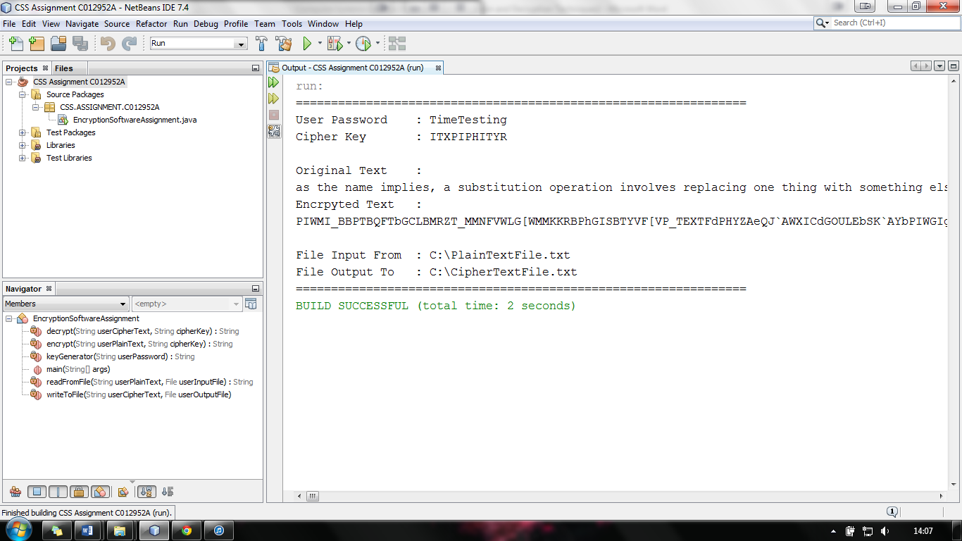

Figure 31 Encryption Time Test 2

Encrypting 100,000 characters

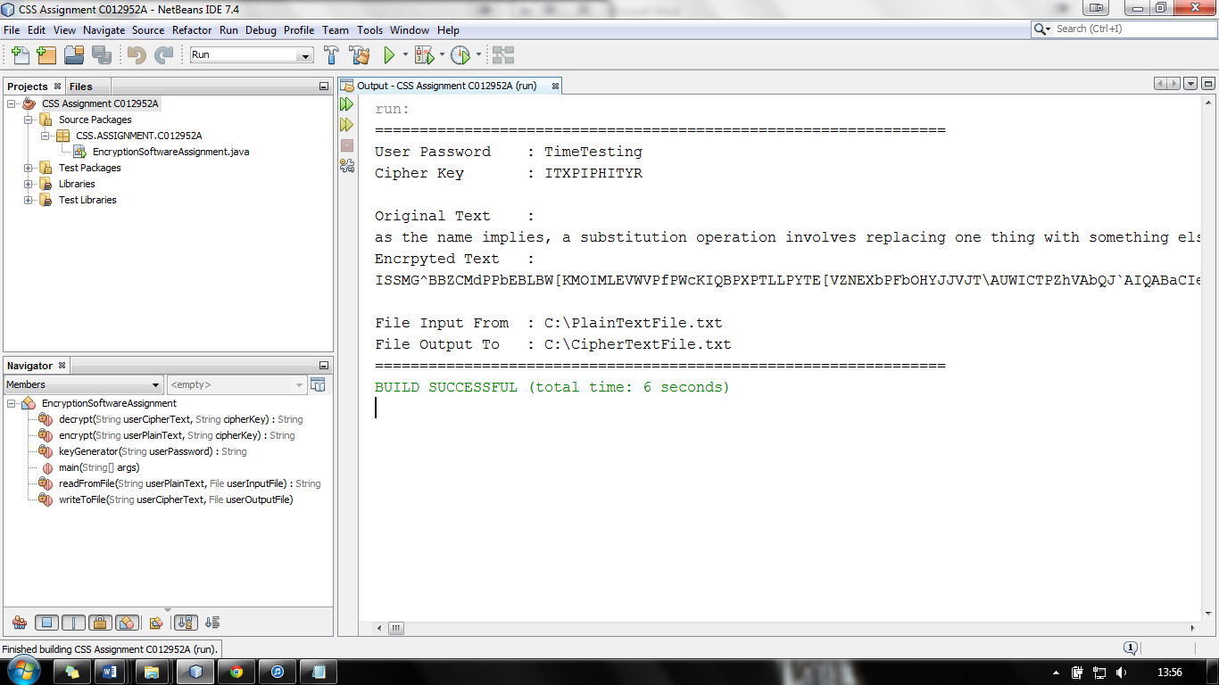

Figure 32 Encryption Time Test 3

Encrypting 150,000 characters

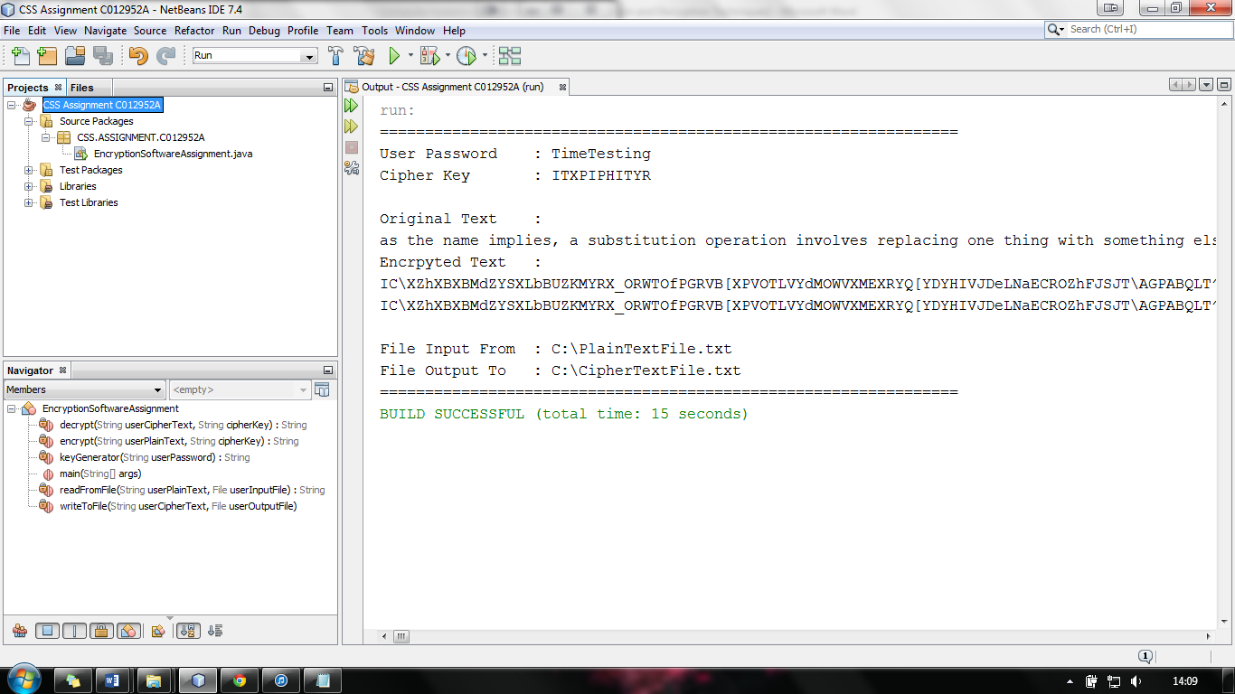

Figure 33 Encryption Time Test 4

**Appendix D**

**Commented Code Listing**

package CSS.ASSIGNMENT.C012952A;

/**

* Imports which are needed for operation in the class

*/

import java.io.*;

import java.nio.charset.Charset;

import java.util.Locale;

/**

* **This class takes arguments from the command line to allow the user to either**

* **encrypt or decrypt a file using a password they have defined which will be**

* **written to a file of their choice.**

*

* **@author** Harry Clewlow (C012952A)

* **@version** 1.0 Build 1 Jan 20, 2014.

*/

public class **EncryptionSoftwareAssignment** {

public static void ***main***(String[] args) {

//initializes variables to store data

String userOptions = null;

String userPassword = null;

String userPlainText = null;

String userCipherText;

String cipherKey;

//initializes the files that will be used at the input and output

File userInputFile = null;

File userOutputFile = null;

//checks the the number parameters passed from the command line

if (args.length == 4) {

//switch statement that checks if the users is encrpyting or decryption

switch (args[0]) {

//if the input is [-e] then the userOptions are set

case "[-e]":

userOptions = args[0];

break;

//if the input is [-d] then the userOptions are set

case "[-d]":

userOptions = args[0];

break;

default:

//outputs an error message to inform the user of the problem

System.*out*.println("ERROR: Invalid Operation ( [-e] / [-d] )");

System.*exit*(0);

break;

}

//checks if the user has entered a password that is more or equal to 10 and less than or equal to 40

if (args[1].length() >= 10 && args[1].length() <= 40) {

userPassword = args[1];

} else {

//outputs an error message to inform the user of the problem

System.*out*.println("ERROR: Invalid Password Length ( More Than 10 / Less Than 40 )");

System.*exit*(0);

}

//checks if the file that the user has input exsists

if (new File(args[2]).exists()) {

userInputFile = new File(args[2]);

} else {

//outputs an error message to inform the user of the problem

System.*out*.println("ERROR: Invalid Input File ( File Does Not Exsist / Wrong Path )");

System.*exit*(0);

}

//checks if the file that the user has input exsists

if (new File(args[3]).exists()) {

userOutputFile = new File(args[3]);

} else {

//outputs an error message to inform the user of the problem

System.*out*.println("ERROR: Invalid Output File ( File Does Not Exsist / Wrong Path )");

System.*exit*(0);

}

} //if the parameters are not equal to four (4) then an error message is output

else {

//outputs an error message to inform the user of the problem

System.*out*.println("ERROR: Invalid Paraments ( Four (4) Parameters Needed )");

System.*exit*(0);

}

switch (userOptions) {

//if the option the user has entered is [-e] (encrypt)

case "[-e]":

//generates the cipher key by using the userPassword variable

cipherKey = *keyGenerator*(userPassword);

//reads the text of the input file and stores it in a string variable

userPlainText = *readFromFile*(userPlainText, userInputFile);

//encrypts the string using the cipher key and stores it in a string variable

userCipherText = *encrypt*(userPlainText, cipherKey);

//printing out message for users for so that marking is easier (can be removed if needed)

System.*out*.println("================================================================");

System.*out*.println("User Password : " + userPassword);

System.*out*.println("Cipher Key : " + cipherKey);

System.*out*.println("**\n**Original Text :**\n**" + userPlainText.toLowerCase());

System.*out*.println("Encrpyted Text :**\n**" + userCipherText);

System.*out*.println("**\n**File Input From : " + userInputFile);

System.*out*.println("File Output To : " + userOutputFile);

System.*out*.println("================================================================");

//writes the string to the output file

*writeToFile*(userCipherText, userOutputFile);

break;

//if the option the user has entered is [-d] (decrypt)

case "[-d]":

//generates the cipher key by using the userPassword variable

cipherKey = *keyGenerator*(userPassword);

//reads the text of the input file and stores it in a string variable

userCipherText = *readFromFile*(userPlainText, userInputFile);

//decrypts the string using the cipher key and stores it in a string variable

userPlainText = *decrypt*(userCipherText, cipherKey);

//printing out message for users for so that marking is easier (can be removed if needed)

System.*out*.println("================================================================");

System.*out*.println("User Password : " + userPassword);

System.*out*.println("Cipher Key : " + cipherKey);

System.*out*.println("**\n**Encrypted Text :**\n**" + userCipherText);

System.*out*.println("Original Text :**\n**" + userPlainText.toLowerCase());

System.*out*.println("**\n**File Input From : " + userInputFile);

System.*out*.println("File Output To : " + userOutputFile);

System.*out*.println("================================================================");

//writes the string to the output file

*writeToFile*(userPlainText, userOutputFile);

break;

}

}

/**

* **This method will encrypts a message using a cipher key and has the**

* **following parameters encrypt(String userPlainText, String cipherKey**

*

* **@param** userPlainText userPlainText is the plain text string from the file

* the user input

* **@param** cipherKey cipherKey is the key that was used for encryption

* **@return** userCipherText userCipherText is a string variable that will be

* output to a file chosen by the user

*/

private static String ***encrypt***(String userPlainText, String cipherKey) {

//converts to upper case so that string can be encrypted by a vigenere cipher

String userResultText = "";

userPlainText = userPlainText.toUpperCase();

//implementation of encryption using a vigenere cipher

for (int i = 0, j = 0; i < userPlainText.length(); i++) {

char c = userPlainText.charAt(i);

if (c < 'A' || c > 'Z') {

continue;

}

userResultText += (char) ((c + cipherKey.charAt(j) - 2 * 'A') % 26 + 'A');

j = ++j % cipherKey.length();

}

//converts it into byte array so that it can be manipulated

byte[] uPlainText = userResultText.getBytes(Charset.*forName*("UTF-8"));

//for loop to itterate through the byte array

for (int i = 0; i < uPlainText.length; i++) {

//checks if the index is a multiple of 3 (adds 14 to the value)

if (i % 3 == 0) {

if (uPlainText[i] + 14 <= 126) {

uPlainText[i] = (byte) (uPlainText[i] + 14);

}

}

//checks if the index is a multiple of 9 (substracts 3 from the value)

if (i % 9 == 0) {

if (uPlainText[i] - 3 >= 32) {

uPlainText[i] = (byte) (uPlainText[i] - 3);

}

}

}

//swaps the char at index 1 (2nd char) with the char at index 9 (10th char)

if (uPlainText.length >= 9) {

byte temp = uPlainText[1];

uPlainText[1] = uPlainText[9];

uPlainText[9] = temp;

}

//reserves the byte array order the scramble the message

byte temp1;

for (int i = 0; i < uPlainText.length / 2; i++) {

temp1 = uPlainText[i];

uPlainText[i] = uPlainText[uPlainText.length - 1 - i];

uPlainText[uPlainText.length - 1 - i] = temp1;

}

//constructs a string from the byte array

String userCipherText = new String(uPlainText);

//returns the encrypted string so it can be written to a user chosen file

return userCipherText;

}

/**

* **This method will decrypt a message using a cipher key and has the**

* **following parameters decrypt(String userCipherText, String cipherKey**)

*

* **@param** userCipherText userCipherText is the encrypted string from the

* file the user input

* **@param** cipherKey cipherKey is the key that was used for encryption and

* will be used to decrypt the message

* **@return** userPlainText userPlainText is a string variable that will be

* output to a file chosen by the user

*/

private static String ***decrypt***(String userCipherText, String cipherKey) {

//converts the string into a bit array so it can be manipulated

byte[] uCipherText = userCipherText.getBytes(Charset.*forName*("UTF-8"));

//reverses the byte array (reverse of encryption)

byte temp1;

for (int i = 0; i < uCipherText.length / 2; i++) {

temp1 = uCipherText[i];

uCipherText[i] = uCipherText[uCipherText.length - 1 - i];

uCipherText[uCipherText.length - 1 - i] = temp1;

}

//swaps char at index 9 with the char at index 1 (reverse of encryption)

if (uCipherText.length >= 9) {

byte temp = uCipherText[9];

uCipherText[9] = uCipherText[1];

uCipherText[1] = temp;

}

//for loop that will itterate through the byte array

for (int i = 0; i < uCipherText.length; i++) {

//if the index is a multiple of 3 it will substract 14 (reverse of encryption)

if (i % 3 == 0) {

if (uCipherText[i] + 14 <= 126) {

uCipherText[i] = (byte) (uCipherText[i] - 14);

}

}

//if the index is a multiple of 9 it will add 3 (reverse of encryption)

if (i % 9 == 0) {

if (uCipherText[i] - 3 >= 32) {

uCipherText[i] = (byte) (uCipherText[i] + 3);

}

}

}

//converts the byte array into a string so it can be decrypted by a vigenere cipher

String userCipherText1 = new String(uCipherText);

String userResultText = "";

userCipherText1 = userCipherText1.toUpperCase();

//implementation of decryption for the the vigenere cipher

for (int i = 0, j = 0; i < userCipherText1.length(); i++) {

char c = userCipherText1.charAt(i);

if (c < 'A' || c > 'Z') {

continue;

}

userResultText += (char) ((c - cipherKey.charAt(j) + 26) % 26 + 'A');

j = ++j % cipherKey.length();

}

//stores the result of the decryption in a string variable

String userPlainText = userResultText;

//returns the plaintext so that it can be shown to the user and output to a file

return userPlainText;

}

/**

* **This method will generate a cipher key from the users password and has**

* **the following parameters keyGenerator(String userPassword**)

*

* **@param** userPassword userPassword is the password the user has entered in

* the command line and is used to generate the cipher key

* **@return** cipherKey cipherKey is a string variable that is used by for

* encryption

*/

private static String ***keyGenerator***(String userPassword) {

//initializes int variable for password length

int uPasswordLength;

//initializes the password for manipulation (puts to uppercase and removes non alphabetic characters)

userPassword = userPassword.toUpperCase(Locale.*ENGLISH*);

userPassword = userPassword.replaceAll("[^A-Z]", "");

//converts the string into a byte array to allow for manipulation

byte[] uPassword = userPassword.getBytes(Charset.*forName*("UTF-8"));

/*checks if the password length is greater than 12 so that all characters will be changed

*so that the password can be masked successfully

*/

if (uPassword.length > 12) {

uPasswordLength = 12;

} else {

uPasswordLength = uPassword.length;

}

/*checks if uPassword[i] will have addition or subtraction preformed and preforms it

*to transform the userpassword into the cipherkey

*/

for (int i = 0; i < uPassword.length; i++) {

if ((uPassword[i] + uPasswordLength) <= 90) {

uPassword[i] = (byte) (uPassword[i] + uPasswordLength);

} else if ((uPassword[i] - uPasswordLength) >= 65) {

uPassword[i] = (byte) (uPassword[i] - uPasswordLength);

}

}

//converts the byte array back into a string

String cipherKey1 = new String(uPassword);

String cipherKey = cipherKey1;

//returns the cipherKey so it van be used to encrypt of decrypt

return cipherKey;

}

/**

* **This method will read text from a file of the users choosing and has the**

* **following parameters readFromFile(String userPlainText, File**

* **userInputFile**)

*

* **@param** userPlainText userPlainText is the string variable that the user

* wants to put the text from the file being read.

* **@param** userInputFile userInputFile is the file the user wants to input

* the encrypted or decrypted text from depending on the option they have

* selected.

*/

private static String ***readFromFile***(String userPlainText, File userInputFile) {

//initializes the bufferreader and stringbuilder

BufferedReader br;

StringBuilder sb;

/*a try and catch statement that will read text from a file until

*it is empty and store it in the userPlainText string variable

*/

try {

br = new BufferedReader(new FileReader(userInputFile));

sb = new StringBuilder();

String line = br.readLine();

/*checks if the line variable is null (if there is any more characters

`*left in the file)and then adds it to the stringbuffer sb

*/

while (line != null) {

sb.append(line);

sb.append('**\n**');

line = br.readLine();

}

//closes the bufferreader

br.close();

//converts the stringbuffer into a string variable

userPlainText = sb.toString().trim();

} //if the string cannot be read from the file this will catch the error

catch (IOException e) {

}

//returns the string variable that has been read from the file

return userPlainText;

}

/**

* **This method will write a string variable to a file of the users choosing**

* **and has the following parameters writeToFile(String userCipherText, File**

* **userOutputFile**)

*

* **@param** userCipherText userCipherText is the string variable that the user

* wants to right to the target userOutputFile.

* **@param** userOutputFile userOutputFile is the file the user wants to output

* the encrypted or decrypted string to depending on the option they have

* selected.

*/

private static void ***writeToFile***(String userCipherText, File userOutputFile) {

//initializes the bufferwriter

BufferedWriter bw;

//a try and catch statement that will write to a file until the string variable is empty

try {

bw = new BufferedWriter(new FileWriter(userOutputFile.getAbsoluteFile()));

//for statement that will go through all the characters in the string

for (int i = 0; i < userCipherText.length(); i++) {

//gets the char value with the index of i

char c = userCipherText.charAt(i);

//checks the char is not a carriage return (if there is a new line within the text)

if (c == '**\n**') {

bw.newLine();

}

//writes the character to the file

bw.write(c);

}

//closes the bufferwriter

bw.close();

} //if the string cannot be written to the file this will catch the error

catch (IOException e) {

}

}

}

**Appendix E**

**References**

1. Charles P. Pfleeger - Pfleeger Consulting Group, Shari Lawrence Pfleeger - RAND Corporation (2006). Security in Computing, Fourth Edition. London: Prentice Hall. 880.
2. Dragonwins. (2010). *Substitutions, Transpositions, and Permutations.* Available: http://www.dragonwins.com/domains/getteched/crypto/subs_and_perms.htm. Last accessed 20th Jan 2014.
3. Brainteasers. (2013). *Codes and Ciphers: Substitution Ciphers.* Available: http://www.braingle.com/brainteasers/codes/substitution.php. Last accessed 20th Jan 2014.
4. Kettering. (2010). Vigenère Cipher. Available: http://www.kettering.edu/sites/default/files/resource-file-download/Vigenere%20Cipher_1.pdf. Last accessed 20th Jan 2014.